Get ready for the

**Super Hero Academy**

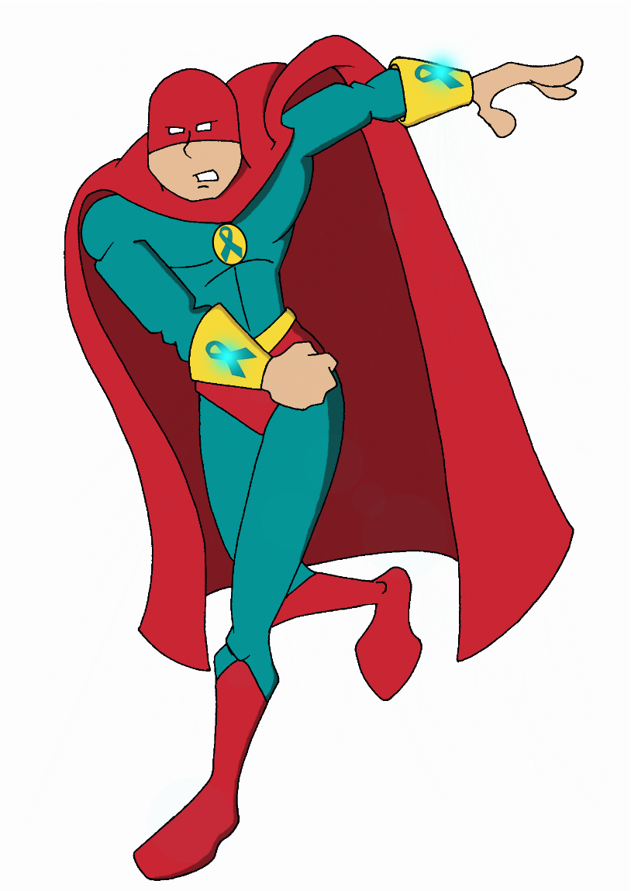**Create-a-Hero Contest!**

Help Purple Lightning and Scarlet

Mask stop the Bystander Effect

by creating a new hero to join the Super Hero Academy.

Your hero must use at least one of the following upstander powers: **vision; listen; confidence; caring; speed**

Your hero costume must have at least one **teal-colored ribbon**

Limit one (1) entry per student

Artwork must be on paper no larger than 8.5” x 11”

Super hero design must be entirely original and free from any copyrighted material

