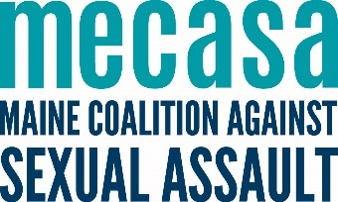
Office of Violence Against Women Rural Grant
Rural Advocate Program
Overview and Reporting Information

Overview
In 2016 Maine sexual assault support centers received two funding sources to expand services to rural survivor and rural communities - VOCA and OVW Rural. Both advocated for using fund to for services, but also the necessary staff time needed to develop relationships, do outreach, and train community partners.
The outcomes in this document and the OVW Rural grant are intended to guide priorities and be a touchstone for work plans, but not dictate what different communities need or what will be successful in your community.
Staffing
Maintain employment of three rural outreach advocates (currently at .875FTE, to be increased to 1FTE) and add an additional .5 FTE in each of the three regions. Each agency would have 1.5 FTEs funded by this grant, a 50% increase in staff hours from our FY16 grant.

MECASA Role
Maintain employment of one .5FTE grant coordinator within MECASA (this is a full-time position combined with related member services activities; funding is already secured for the additional .5FTE). The coordinator provides ongoing support and technical assistance to the three advocates, which includes monthly peer-resource-sharing calls; an online toolkit; training of trainers; resources such as outreach materials; etc. MECASA will also provide administrative support from their Quality and Compliance Coordinator and their Financial Coordinator; both positions will ensure reporting and financial management of grant funds are compliant.
Reporting
MECASA will be relying on a number of measures to track and report the success of this initiative. Most of those are items that are already being tracked in the statewide EmpowerDB database. In some cases, simple changes can be made to the database to ensure that we are capturing all of the information.
Biannual, MECASA staff will request some information from centers to help answer the narrative questions, give info not reflected in EmpowerDB, and supplement/clarify Empower data.
Activities | Statewide 3 year Grant Goals
Ongoing periodic outreach to allied providers. | 90 outreach meetings
Increasing the capacity of providers in rural communities to respond to sexual assault by providing training. | 1050 professionals and community members trained; 5 trainings created or adapted (including HT)
Increasing the capacity of providers in rural communities to respond to sexual assault by developing cross-referral protocols. | -
Representing sexual assault services at community-based coalitions, network meetings, etc. | 75 meeting convened; 75 meeting attended.
General awareness and outreach efforts (tabling, postering, social media outreach, etc.). | 105 tabling events; distribution of 750 posters.
Expand rural advocacy services. | 775 hours of one-to-one advocacy and accompaniment; advocacy to 200 clients
Offer on-site services hosted by a community partner (AKA drop-in hours/services) | 200 hours of on-site services hosted by a community partner; 90 clients connected via drop-in
Increase the accessibility of support groups for rural survivors by utilizing technological infrastructure & community partnerships. | 12 televideo groups; 65 televideo participants; 60 chatroom participants; 6 support groups; 5 co-delivered support groups
Engage in primary prevention programming with parents, educators, and students (using statewide training templates). | 75 parent; 90 educators; 750 student participants.
Through the sum of this work, increasing the awareness and understanding of sexual violence and sexual assault support services; and increasing the accessibility of those services. | ---

Center Reporting for Biannual Grants
MECASA will coordinate and submit a biannual grant reflecting Rural Advocate and MECASA work.
Reporting periods are January 1 – June 30 and July 1 – December 31.
Definitions & Clarifications
When inputting your training, outreach, and education actives in EmpowerDB, consider these definitions (clarified for us by OVW grant reviewers at Muskie).
Outreach
Introduction to sexual assault support center advocate and services, very basic introduction to sexual violence, introduce self and how to contact us. Ex: presentation to Rotary Clubs, food pantry staff, meet and greets at hospital, joining a service providers staff meeting
Coalition Building
Represent sexual assault support center at ongoing meetings, whether giving updates or not. Ex: Knox county providers meeting, BCC
Training
When providing training for people who work with survivors in a professional capacity, where they have a formal role in the system responding to sexual violence. These trainings build skills for these professionals to do their job. Ex: law enforcement, SAFEs, District Attorney, medical providers, mental health providers, first responders, correctional officers, school-based professionals.
Community Education
Sexual Violence is a community issue and impacts survivors; how can participants be a part of informal response and connect someone to services. Ex: presentation to social work students, hairdressers
Notes: Training educators would fall under training professionals if it is expanding skills regarding how to respond to a disclosure in a formal capacity. Training educators would fall under primary prevention if the content was related to risk reduction, consent and healthy sexuality.
- When tracking trainings & community ed in Empower, always describe your audience even if you also picked from the dropdown list. For example, if in the dropdown list you choose “Community”, but describe the audience further in the space provided, perhaps it’s ‘parents’ or ‘Belfast community members’. Or if you choose “Providers (Service Providers)” include “substance abuse counselors” or “WIC staff” in the space below.
- Same with topic: always include what you trained about, even if it is covered by the dropdown list.
Drop-In Services
Advocate has a regularly scheduled time for drop-in services (or “office hours”) located on-site at a host location, such as a school, shelter, jail, residential facility, community setting (i.e. library, WIC office), etc. The individuals who participate may be impromptu or previously scheduled (these work best when the host (guidance counselors, librarians) are making active referrals for survivors.

Reporting – drop-in is captured in the Groups and Events with an option for drop-in services. Please include the total time spent, regardless of whether anyone comes to participate. Clients should all get a client profile and activity (one-to-one) in the client portion of the database.

How to pull Facebook reach

Facebook reach is the number of unique people who saw your content Not just your posts, but older posters, pictures, your “about section”, etc. It affects all other metrics like: engagement, likes, comments, clicks and negative feedback. There are different kinds of reach: post, page, organic, viral, and paid.

Page Reach vs. Post Reach
When we talk about reach there are two categories, page reach and post reach. Page reach always gives you the number of people who viewed any content associated with your page. This not only includes users that viewed your posts but also users that viewed e.g. a photo album or users that saw any stories about your page in their news feeds. Other than that, the page reach also includes users who have been reached by your ads.

Post reach describes the number of people who saw a certain post of your page. So for every post a page posted, you can see the number of people you reached.
Reporting Reach
When we at MECASA talk about Facebook reach, we are talking about your “Total Reach.”

How to pull Facebook reach
- Go to your page.
- At the top, click “Insights.”
- On the left, click “Reach.”
- Top right select the dates you want to know about.
- Scroll down to “Total Reach.”
- Use your curser to select the far left of the graph and drag it all the way across.
- A table with your chosen date range and reach should pop up.
- Use your curser to select the graph.
- Copy the graph.
- Paste it into an excel doc.
- Select the column representing “Total Reach” and record the sum.
- That is your Total Reach for those dates.

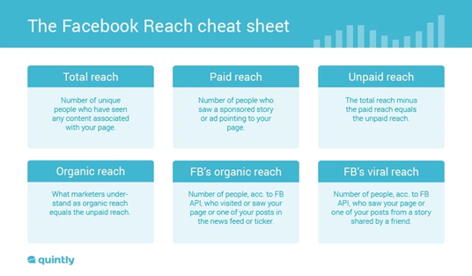

https://www.socialmediaexaminer.com/facebook-reach-guide/
https://www.quintly.com/blog/facebook-post-reach-explained

