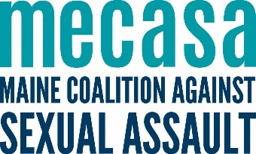
Rural Advocate Work Plan
with OVW Rural measures

Use the Community Mapping for Advocates tool from the Southern Maine Workers’ Center to explore who your priority community members and allied providers are when building your rural program. Also think about the following questions:
What outreach populations are a priority? (service providers, community leaders, civic organizations, etc).

What training populations are a priority?

What do you want those populations to know about your agency and program in 5 minutes?

What are some possible locations for drop-in services? Where do people naturally gather?

Where might materials be posted/dropped?

What is your vision for this work?

Where do you want to be in a year?

Activity | Measures | Priority audience | Goals  Next 3-6 months | Goals  Next 6-12 months | Resources needed
Outreach to allied providers. | Number of outreach meetings; Increase in outreach meetings over time.
Provide training to allied providers | Number of trainings delivered; number of trainees
Develop cross-referral protocols with allied providers. | Increase in referrals coming from community partners.
Represent sexual assault services at community-based coalitions, network meetings, etc. | Number of coalition meetings attended or convened.
General awareness and outreach efforts | Number of tabling events; number of awareness materials distributed.
Deliver direct services through drop in hours. | Number of individuals served; number of contacts.
Deliver specialized and televideo support groups, | number of support groups held; number of support group participants.
Deliver core victim services. | Number of individuals served.
Engage in primary prevention programming with parents, educators, and students (using statewide training templates) | Number of parent, educator, and student participants.

