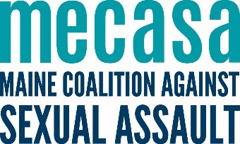
Rural Advocate Work Plan
Use the Community Mapping for Advocates tool from the Southern Maine Workers’ Center to explore who your priority community members and allied providers are when building your rural program. Also think about the following questions:
What outreach populations are a priority? (service providers, community leaders, civic organizations, etc).

What training populations are a priority?

What do you want those populations to know about your agency and program in 5 minutes?

What are some possible locations for drop-in services? Where do people naturally gather?

Where might materials be posted/dropped?

What is your vision for this work?

Where do you want to be in a year?

Activity | Measures | Priority audience | Goals  Next 3-6 months | Goals  Next 6-12 months | Resources needed
Outreach to a growing group of allied providers. | Number of outreach meetings; Increase in outreach meetings over time.
Provide training to allied providers, including cross-referral protocols. | Number of trainings delivered; number of trainees; Increase in self-described content knowledge and skills of trainees.
Develop cross-referral protocols with allied providers. | Increase in referrals coming from community partners.
Represent sexual assault services at community-based coalitions, network meetings, etc. | Number of coalition meetings attended or convened.
General awareness and outreach efforts (tabling, postering, etc.). | Number of tabling events; number of awareness materials distributed.
Deliver direct services through drop in hours. | Number of individuals served; number of contacts.
Deliver direct services through specialized and televideo support groups, and core victim services. | number of support groups held; number of support group participants.
Activity | Measures | Priority audience | Goals  Next 3-6 months | Goals  Next 6-12 months | Resources needed
Deliver core victim services. | Number of individuals served.
Enhance your agency’s own accessibility and appropriateness programming by supporting shifts in organizational policy or practice. | Increase in host center perceived change in knowledge, skills and accessibility and appropriateness of services.
Promoting protective factors and reducing risk factors by engaging in primary prevention programming with parents, educators, and students (using statewide training templates)* | Number of parent, educator, and student participants.
Through the sum of this work, increasing the awareness and understanding of sexual violence and sexual assault support services; and increasing the accessibility of those services. | Increase in stakeholder communities perceived change in knowledge, skills and accessibility of services.
*OVW grantees only

