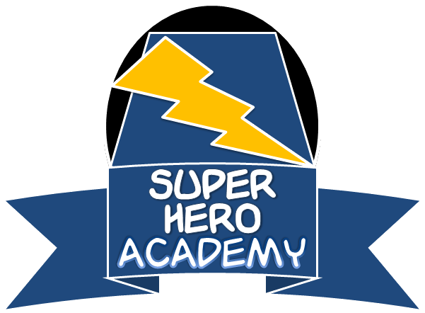
Create a Hero Contest

2016

ENTRY FORM
(Please print)

Student Name: ___________________________________________________ Grade: ____________

Name of Your Super Hero: ____________________________________________________________

Your Hero’s Power(s): ________________________________________________________________

School Name: ______________________________________________________________________

Name of Teacher/Adult who Approved Your Entry: _________________________________________

Name of Classroom Teacher: __________________________________________________________

Parent/Guardian Permission
I am aware that my child is participating in the Super Hero Academy Create a Hero Contest and that all entries become the property of the Sexual Assault Crisis & Support Center (SAC&SC). I am also aware that the entry may appear on the SAC&SC website or in/on related promotional materials.

I certify that this entry was created entirely by the student above and that it contains only original artwork and no copyrighted characters or artwork are used.

Signature: __________________________________________________ Date: _________________

Bring your illustration and completed entry form to your school counselor, or you may scan and email your illustration and completed entry form to the following email: sean@silentnomore.org, using the subject line: “ENTRY: (hero name).”

Please submit both contest entry and completed entry form no later than June 1, 2016

Thank you for entering the contest and best of luck!

