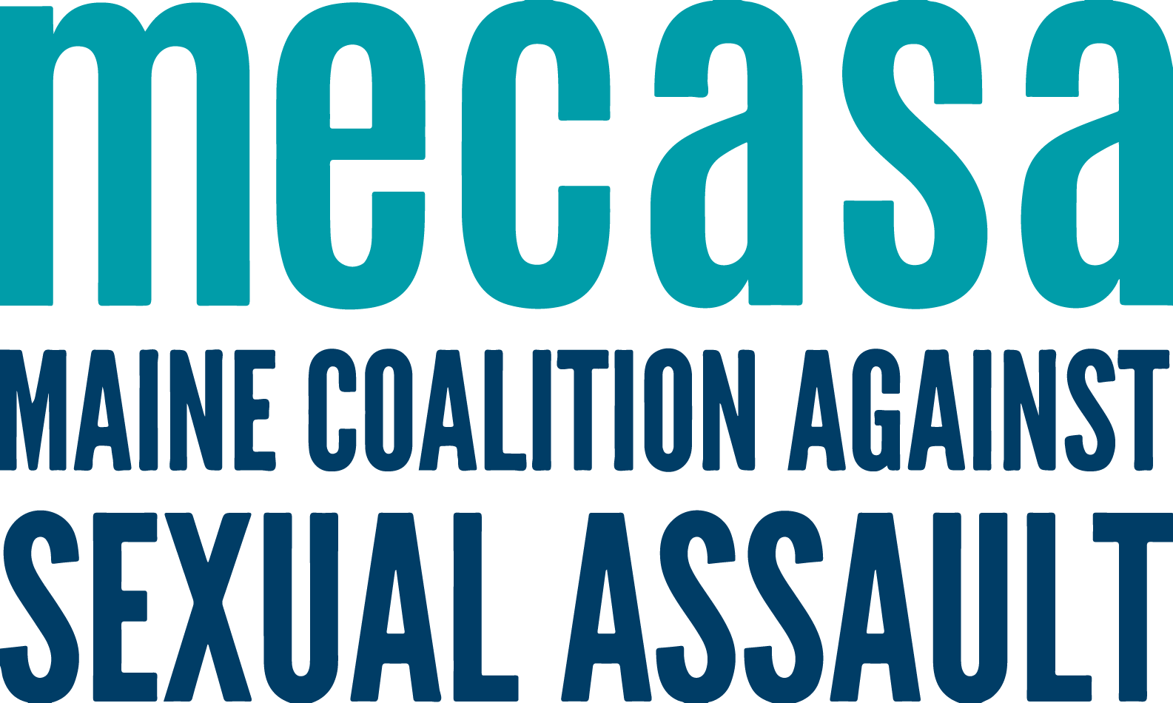
Helpline Volunteer Managers
Peer Support Call
Approved on June 15, 2023, by the MAC

Background
In January 2023 as part of MECASA’s Volunteer Advocate Recruitment Support Offerings, a one-time peer sharing call was held for center staff who engage in helpline volunteer recruitment. That call was one of the first designated spaces for center staff to share information and ideas specifically pertaining to the recruitment of volunteer helpline advocates, and for MECASA to better understand centers’ needs. At that call several center staff expressed the desire for an ongoing peer call to continue communicating about helpline volunteer recruitment and management.

Additionally, it was thought the supervisors' cohort call could be a place for volunteer program managers to connect with peers about supporting and supervising volunteer advocates; however, as that call became more established it became clear that the issues involved in supervising volunteers were different and a separate cohort would be needed.

Group Purpose
The Helpline Volunteer Managers peer call will provide a designated place and time for center staff to come together to discuss issues related to managing helpline volunteer advocate programs, such as recruitment, retention, recognition, support, supervision, and ongoing training.

Timeframe
- This peer call will begin in July 2023 and meet bi-monthly for 90 min. (Day and time TBD after checking in with center staff.)
- Calls will have topics determined in advance; calls times, topics, and zoom links will be posted on the toolkit.
- Calendar invitations will be sent for each meeting.

Members
- Any center staff member recruiting, training, and supporting helpline volunteers or overseeing a helpline volunteer management program.
- Join only after reaching agreement with their ED.
- Share and provide feedback, seek additional information from their center as needed.
- Communicate about meetings and activities of the group with their supervisor and/or ED.
- Inform the work of the group with knowledge and expertise about their communities.
- Collaborate on shared projects that reflect both centers’ expertise and a statewide purpose.

Group Guidelines
The standing group guidelines for all MECASA Peer Support Calls are:
- Acknowledge and learn from different approaches to the work
- Direct and ethical communication – if you have an issue with a singular agency or person, have that conversation directly, not in the Peer Support Call
- Do not share client information, including any identifying information

