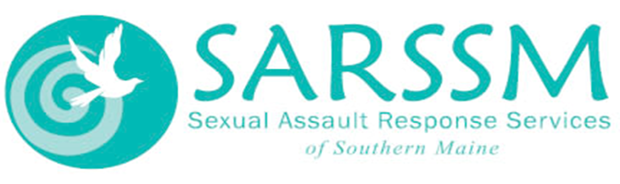
HOSPITAL ACCOMPANIMENTS

FAQs and Info about Coronavirus Response

Q: What is a hospital accompaniment?
A: A hospital accompaniment is something that all Sexual Assault Centers in Maine and many other states offer to survivors/victims of sexual violence. It is an emergency based, in-person service that is offered 24/7 in Maine no matter the area.

Q: Who provides accompaniments?
A: Specially trained advocates at Sexual Assault Centers provide in-person accompaniments. They go through a 40-hour advocate training to be qualified to provide this type of support to survivors!

Q: What exactly is an advocate?
A: We help people who have been sexually assaulted, harassed, or abused. We do this by following their lead. Survivors know their lives best - we are here to help talk about options, what happens next, or just listen. We might do this by:
- Be there for you at the hospital and/or if you want to report to the police
- Help you fill out paperwork
- Help you find other services in our community
- Explain your options
- Support your friends and family if needed

Q: Are advocates/centers providing accompaniments during the Coronavirus pandemic?
A: Unfortunately, SARSSM and other Sexual Assault Centers will not be providing in-person accompaniment services. Medical Providers have encouraged the minimization of visitors at the hospital and we want to do our part in minimizing the spread of this virus as much as possible. We will offer phone support during a Sexual Assault Forensic Exam, if consent is given to do so.

Q: Are hospitals still doing Sexual Assault Forensic Exams during the Coronavirus Pandemic?
A: Hospitals are doing all they can to keep all patients safe. People should still come to the Emergency Department if they need a Forensic Exam. Survivors can call ahead to speak to triage and/or the charge nurse if they want to know how to what to expect upon arrival (additional screening, change in entrance, etc.). If you are already at the hospital no worries: you will still be able to be seen by a nurse! It may take a little bit longer than usual, but please know you can call our helpline anytime for support, while you wait. Its okay to advocate for yourself and check in with medical personnel at the hospital about wait times.

Q: Will there be other supports in place for survivors?
A: Of course! We are so happy to announce that other helpline services will continue on as usual! A survivor, concerned other, or provider can access our phone support, which is our 24/7 helpline at 1-800-871-7741. Although an advocate won’t be able to provide in-person support, they will absolutely be there via the phone to provide a caring hand.

Q: How exactly do I use the helpline?
A: Great question! Accessing the helpline can be overwhelming. There are a few ways to do it!
- You can call the helpline at 1-800-871-7741. Between the hours of 8am -11pm (M-F), it is more than likely that you will get to speak with an advocate right away! This advocate won’t need your name or contact information to support you. If it is between the hours of 11pm – 8am and on the weekends, you may get our answering service. The answering service is trained to get your name, number and county, so that an advocate can be paged immediately. It may take 10 – 15 minutes to get a call back.
- You can text the helpline at 1-800-871-7741. You just text that number like you would any other. At this point, an advocate is not guaranteed to respond, in case they are on break, but it is a great way to remain anonymous and get the support you need! This service is only available between the hours of 8am – 11pm, M-F.
- You can also chat with an advocate by heading to our webpage at www.sarssm.org. The same rules apply here as they do to texting the helpline. Only available 8am – 11pm, M-F.

Q: What happens when I leave the hospital?
A: Before you leave the hospital, you can ask your nurse if they can refer you to our services for a follow up call and on-going support. Our ongoing services are called SART (Sexual Assault Response Team) services and here is what they might look like:
- Give emotional support at any point.
- Help the survivor through systems that might be hard to deal with (like court, healthcare, workplace, and schools).
- Answer questions about any kind of process the survivor might go through (like reporting to police).
- Help the survivors' friends and family if needed.
- Refer the survivor to other community help and services if needed.
- Goes with and supports the survivor through any part of a process (like reporting to police, filing court paperwork, or applying for
​ Victims’ Compensation).
- Help the survivor plan for safety.
- Help the survivor plan for their needs now and in the future.

A: How might you be getting home? Sexual Assault Centers can help get you home safely by calling you a taxi, which we pay for. We can also safety plan over the phone with you before you get home, in case you aren’t feeling great about leaving the hospital.

*A reminder that any part of a Sexual Assault Forensic Exam is in YOUR control. This means that you can deny any part of this process, because it can only be done with your consent. Give us a call at 1-800-871-7741, if you need anything. Our services are completely free and confidential! If you are under the age of 18: please check in with the medical providers taking care of you or call our helpline for more information about how it impacts your confidentiality.

