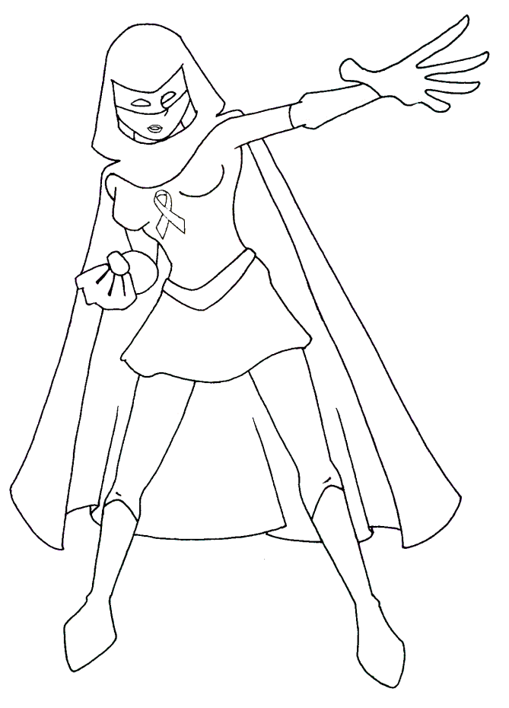

Across
1. Purple _________ was the Super Hero Academy's first recruit.
3. Heroes lend their _____ to those who need help.
6. _______ is when someone uses their words or their bodies to hurt others (teasing, fighting, excluding).
7. The Super Hero Academy's second recruit was the Crimson ____.
8. A hero's worst enemy is The Bystander _____.
10. The person being bullied is sometimes called the ______.
12. Heroes are the first to help because of their super _____.
Down
1. A hero will ______ when a friend has been hurt and needs to talk.
2. We used our powers to help _______ get back home.
4. You are enrolled in the Super Hero _______
5. If you're being bullied or harassed, it's important to tell an _____ you trust.
6. When bullying happens, a _________ chooses not to help.
9. A hero will use his/her ____ to see problems, like bullying.
11. Heroes have the _____ to care about those who are being bullied.

Word Bank: Academy, adult, bullying, bystander, effect, eyes, hand, heart, lightning, listen, mask, Oracle, speed, target

