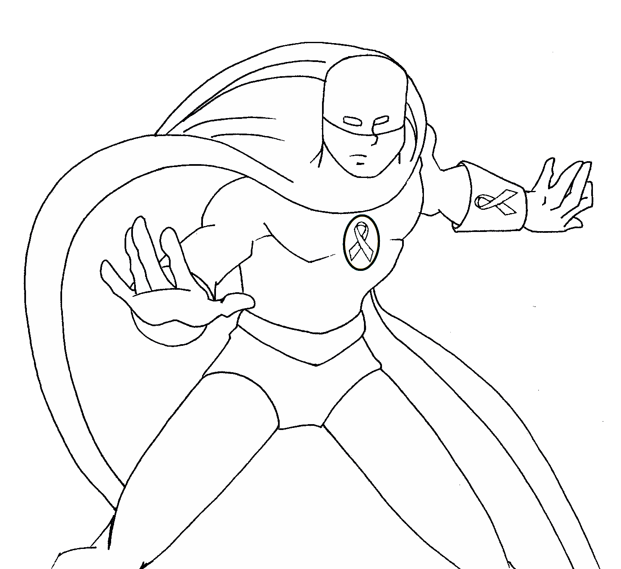

Super Hero Academy is a program of the Sexual Assault Crisis & Support Center

silentnomore.org/super-hero-academy.html

CONFIDENCE: I WILL STAND UP FOR OTHERS