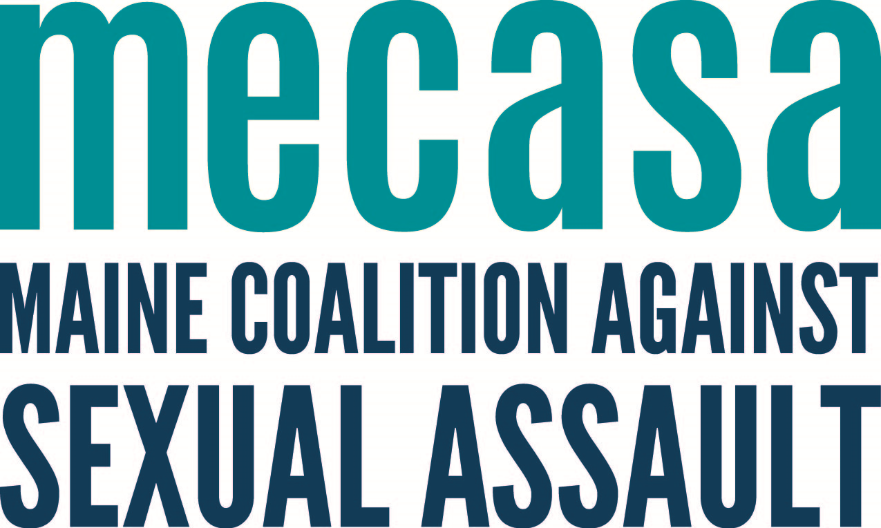
College Student Guide to Title II

What is Title II?

The Americans with Disabilities Act (ADA) is a civil rights law that prohibits discrimination and guarantees that people with disabilities receive reasonable accommodations in all areas of civilian life, including educational programs. Title II of the ADA specifically prohibits discrimination from programs and institutions that receive federal funding, and students that believe that they have been discriminated against because of their disability have the right to file a federal complaint with the Office for Civil Rights of The Department of Education.
Things to know
- Under the ADA, a person has a disability if they have a physical or mental impairment that "substantially limits" one or more "major life activities,” have a record of such an impairment, or are regarded as having such an impairment. Students with disabilities have certain rights to academic, and living accommodations, and, for survivors of sexual violence, Title II goes hand in hand with Title IX.
- Both depression and posttraumatic stress disorder are covered as disabilities under Title II of the ADA, as are bipolar disorder, borderline personality disorder, cerebral palsy, and schizophrenia among other psychiatric illnesses.
- The ADA also bars institutions from using someone disability to disqualify them from access to an education program, and form using their disability against them in the context of a sexual assault complaint investigation.

How can Title II help me?
The Department of Education requires colleges and universities to provide students with appropriate academic adjustments and auxiliary aids and services that are necessary to afford an individual with a disability an equal opportunity to participate in the school's program. Examples of auxiliary aids that may be required are taped texts, notetakers, interpreters, readers, and specialized computer equipment.
If you are a student employee, you have Title II protections, too. Your employer has to make reasonable accommodation only if they know about your mental illness. If an employee with a known disability is having a hard time doing their job, an employer may ask whether the employee is in need of a reasonable accommodation. An employer cannot ask questions about your medical or psychiatric history during an interview.
Where can I get more information?
Title II
https://title2.ed.gov/Public/Home.aspx
ADA.Gov
http://www.ada.gov/ada_title_II.htm
Title II Overview
http://endrapeoncampus.org/title-ii/

