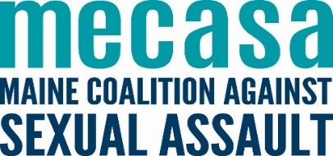
College Student Guide to The Campus SaVE Act

What is The Campus SaVE Act?
The Campus Sexual Violence Elimination Act (SaVE Act) was once a standalone bill whose components were instead applied to the Violence Against Women Act (VAWA) amendments to the Clery Act. The Campus SaVE Act updated the Clery Act, expanding the scope of this legislation in terms of reporting, response, and prevention education requirements around rape, acquaintance rape, domestic violence, dating violence, sexual assault, and stalking.

Things to know
- Transparency: SaVE requires that incidents of domestic violence, dating violence, sexual assault, and stalking be disclosed in annual campus crime statistic reports. Additionally, students or employees reporting victimization will be provided with their written rights.
- Accountability: SaVE clarifies minimum standards for institutional disciplinary procedures covering domestic violence, dating violence, sexual assault, and stalking to ensure that proceedings are prompt, fair, and impartial.
- Education: SaVE instructs colleges and universities to provide programming for students and employees addressing the issues of domestic violence, dating violence, sexual assault and stalking.

How can The Campus SaVE Act help me?
SaVE establishes collaboration between the U.S. Departments of Justice, Education, and Health and Human Services to collect and disseminate best practices for preventing and responding to domestic violence, dating violence, sexual assault, and stalking.

Where can I get more information?
Campus SaVE Act
http://thecampussaveact.com/faq/
Campus SaVE ACT
http://www.campussaveact.org/
Clery Center
http://clerycenter.org/campus-sexual-violence-elimination-save-act

