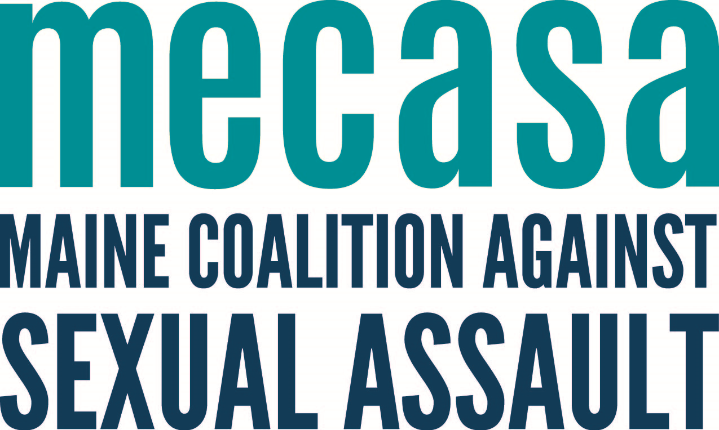
College Student Guide to The Clery Act

What is The Clery Act?
The Jeanne Clery Disclosure of Campus Security Policy and Campus Crime Statistics Act requires United States colleges and universities to disclose information about crime on and around their campuses. The Act is enforced by the United States Department of Education.

Things to know

- The Act requires colleges to publish an annual security report; disclose crime statistics for incidents that occur on or nearby campus; issue timely warnings about crimes that pose a serious or ongoing threat to students and employees; and develop emergency responses, notifications, and testing policies.
- Crimes that must be reported include homicide, murder, manslaughter, forcible and non-forcible sexual offenses, domestic violence, dating violence, stalking, arson, aggravated assault, robbery, and burglary.
- Hate crimes must also be reported by category, including by the following: Race, gender, gender identity, national origin, religion, sexual orientation, ethnicity, and disability.

What is the Campus Sexual Assault Victims' Bill of Rights?

The Campus Sexual Assault Victims' Bill of Rights was passed by Congress in 1992 and requires colleges and universities to provide the following:
- Accuser and accused must have the same opportunity to have others present.
- Both parties shall be informed of the outcome of any disciplinary proceeding.
- Survivors shall be informed of their options to notify law enforcement.
- Survivors shall be notified of counseling services.
- Survivors shall be notified of options for changing academic and living situations.

How can The Clery Act and Bill of Rights help me?
If you believe your college has violated the Clery Act and/or the Campus Sexual Assault Victims' Bill of Rights, you have a right to file a Clery complaint—a document that details a single case or multiple cases in which your college violated these federal acts. The length of this document varies, depending upon the number of cases included and the level of detail provided. Complaints typically include appendices with supporting documents. Clery complaints are organized by type of violation, not complainant.

Each complainant in a Clery complaint is a student, staff, or faculty member who has experienced an incident pertaining to the schools misreporting of crime—discouraged from reporting a sexual assault, timely warning not issued after a sexual assault, being asked to alter crime statistics.

Complainants can either be named or anonymous, and they can include as much or little detail about their case as they would like. Since Clery focuses on the college’s handling of sexual misconduct, complaints detail experiences with the college or university. Survivors do not have to recount their experience of sexual misconduct in the Clery complaint.

Anyone who believes that a college or university that receives federal funding has misreported crimes, or perpetuated a culture that prevents crime reporting, can file a Clery complaint against that institution. Faculty, alums, and other concerned people can file a Clery complaint on behalf of survivors.

You do not need a lawyer to file a Clery complaint, and filing is free of charge. However, legal counsel is a personal choice and may work for some and not for others.

To file a Clery complaint, you can call in, mail, or e-mail. You will receive confirmation of receipt within two weeks of filing:
- Call: You can call 1-800-1-FED-AID to lodge your Clery complaint.
- Mail: Clery complaints should be sent to the regional Department of Education office that has jurisdiction over your college/university. A list can be found at: http://www2.ed.gov/offices/OSFAP/services/casemanagement.html
- E-mail: To file a Clery complaint by email, send a message to the regional office (see above) and to clerycomplaints@ed.gov. Most complaints are too large to send as one email attachment, so the complaint and appendices may be sent as separate documents.

The U.S. Department of Education has the ability to fine colleges and universities up to $35,000 per Clery violation. Clery can help schools comply with the law, and also monitor schools so that current and future students are protected.

Once an investigation is open, it could take several years to complete if numerous complainants are involved. Oftentimes, Clery investigators start their investigation promptly, and they visit campus to interview the complainants who want to be interviewed, and college or university staff within six months of opening an investigation.

The time it takes to draft a Clery complaint varies widely, depending upon the number of alleged violations in the complaint and the number of people drafting the complaint. A complaint with just a few violations should take a few hours for one person to write up, but most Clery complaints cite multiple violations. Filers generally find that Clery complaints take less time to complete than Title IX complaints, although both processes are time intensive at the start.

Named complainants will have their names listed in the Clery complaint, while anonymous complainants will only be identified by a number. The DOE will not publicly release any names in the complaint, but in rare instances, a complaint gets leaked to the press from someone, and named complaints become known. It is generally best to have at least one person who is willing to be a contact/point person who can be named. If you use your name and the school has a file from your case, Clery will request to see those files, but they are private and will not be shown to anyone else.

Where can I get more information?
Clery Center
http://clerycenter.org
The Clery Act in Detail
http://knowyourix.org/the-clery-act-in-detail/
Clery Act Info
http://www.cleryact.info/

