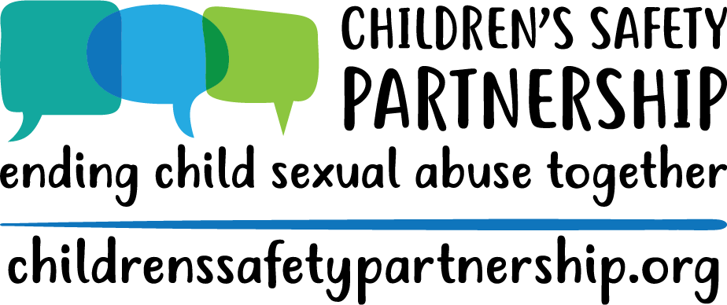

Understanding and Responding to Child Sexual Abuse
Personnel Awareness Training
1-hour training

Materials | -- | --
- Poster titled “Hopes for the Day”
- Poster titled “Group Agreements”
- Sticky notes
- Agenda
- Markers
- “Responding to Sexual Behaviors” handout

Hope(s) for the Day | Slide 1 | --
- One per sticky note, as many as wish and post on the newsprint labeled Hopes for the Day

Introductions | Slide 2 | 3 mins
- Introductions & Pronouns
  - Explain that pronouns are simple way to promote inclusivity in a space.
Group Agreements & Outcomes | Slides 3-4 | 4 mins
- Ask for group agreements (Record answers up on poster paper to refer back to throughout the training). Be sure they include:
  - Ask the group for agreements, be sure they include… Respect one another, use respectful and inclusive language at all times, be aware of body language, commit to practicing giving/receiving feedback, affirm others, even when disagreeing, question your assumptions; ask clarifying questions; be present; confidentiality!
  - Write up on poster paper to refer back to through training
- Hopes for the Day
  - Summarize trends on Hopes for the Day poster. Review stickies and be clear with what will be covered and what won’t...might be another training or future addition.
- Review agenda for the day
- Review outcomes:
  - Provide overview of the state law and policy regarding CSA prevention education and response
  - Increase understanding of child sexual abuse
  - Increase awareness of sexual development, including appropriate and inappropriate behaviors
  - Increase ability to effectively respond to student disclosures, sexual behavior, or suspicions of child sexual abuse
  - Understand school district’s response and referral system to incidences of suspected child sexual abuse
  - Increase awareness of local resources
- Emphasize to participants:
  - Ultimately we want people to know how to appropriately respond to behaviors and how to make referrals keeping in mind, do no harm!
  - You do not have to handle this by yourself, the system is very important.
  - Some people/staff will be more comfortable responding then others and that is okay.
  - Use those who are more comfortable and trained to respond.

Overview of Law | Slides 5-9 | 5 minutes
- Slides 6: Review highlights of the law
- Slide 7: Go to the website, overview layout, highlight a few pages, and focus on the school systems section.
- Slide 8: Resources
- Thoughts on the law and/or policy? Q & A

Understanding Child Sexual Abuse | Slides 9-15 | 10 minutes
- Slide 10: Read the definition or ask for a volunteer to read it aloud. You may want to ask whether any part of this definition surprises anyone.
- Slides 11-13: Review stats
- Slide 14: Open “How often does CSA happen?” drop-down under “Your Questions” on website
  - Review statistics in this section
  - Talk about nuances around sexual assault statistics
    - sexual abuse it the most underreported crime, imagine then for children
    - sometimes it takes long periods of time for survivors to report
    - Is the data collected retrospectively, or based on reports made?
    - Crime data vs disclosures
    - Basically, it's complicated.
- Slide 15: Who Sexually Abuses Children?
  - Are these numbers surprising?

Understanding Sexual Development | Slides 16-23 | 10 minutes
- Slide 17: Children’s behaviors typically fit into one of two categories: developmentally expected and potentially problematic. However, just because a behavior is “typical” or “developmentally expected” does not mean it is acceptable or appropriate in every context or in every family. Families, schools, or early education programs can make decisions about what behaviors are appropriate within each of those contexts. What this discussion does is provide a child development framework for understanding children’s sexual behaviors. Sometimes developmentally expected behaviors can still feel icky, but don’t make decisions based on that feeling, instead make decisions based on knowledge.
- Slides 18-21: Signs/behaviors broken down by age group. Be sure to leave space for questions or surprising reactions. It can be helpful to remember that the motivation behind children’s sexual behaviors is different than that of adults. For example, when children touch their own genitals, or masturbate, they do so because they have learned that the touching feels good and not because they associate it with sex. Some children will masturbate as a way of calming down or relaxing, just as other children will twirl their hair or suck their thumb to accomplish the same self-soothing effect.
- Slide 22-23: While having a list can be helpful, there is often a thin line between developmentally expected behavior and potentially problematic behaviors. If you’re unsure, report behavior. Questions about the list? Anything that needs to be added?
- Questions?

Responding to Sexual Behaviors | Slides 24-34 | 15 minutes
- Slide 25: Here are some words to use when responding to a behavior or interaction that model for the child a way of communicating that is clear and helps children learn empathy and accountability for their behavior. Remember, remain calm and continue to assess the situation. Depending on the behavior, calmly redirect when you can.
  - Model communication: be clear & direct, label the behavior for the child
  - Foster empathy: respond from a personal place and label your feelings (or another’s)
  - Promote accountability: if needed, ask clarifying, open ended questions. Then, set an appropriate limit, rule or expectation to promote the child’s responsibility for the behavior.
- Slides 26-28: Introduce model
  - Give example: I see you trying to kiss your classmate on the cheek. Your classmate pulled away and was visibly uncomfortable. At school, we do not kiss each other.
- Slide 29 & 30: Tips for responding, Examples and what to do if age appropriate
  - Refer folks to “Responding to Sexual Behaviors” Handout
- Slide 31: Things to consider when you receive a disclosure
- Slides 32-34: What if you suspect an adult of CSA? Acknowledge that this is a tricky and uncomfortable situation. Point out red flags and talk about resources – school policy, helpline, etc., CSEC

Response and Referral System | Slides 35-40 | 10 minutes
- Slide 35: This section is about reporting CSA specifically, this is not a mandated reporting training. You all should have that as well.
- Slides 36-39: Review slide content

Connections | Slide 41 | 10 minutes
- Slide 41: Talk about local resources – helpline, local centers, Title IX coordinator
- End by going back to website again
- We want feedback/thoughts/comments on the website

Questions | -- | --

Evaluations | -- | --

