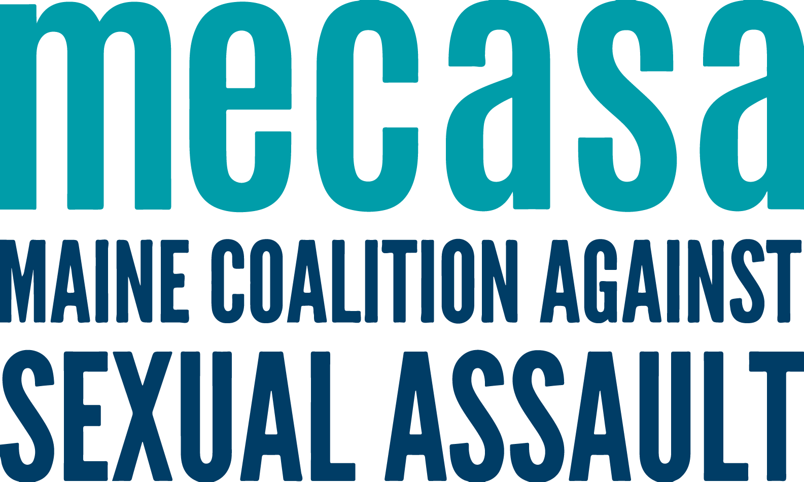
Statewide Helpline Workgroup

Group Description and Purpose
The Statewide Helpline Workgroup, as with other MECASA hosted groups, is a project specific group that has received approval from center directors. It is a collaborative group where centers receive support, present complex issues in exchange for ideas and guidance, participate in group problem solving, and come to agreements around shared helpline protocols and policy changes. Additionally, this group serves as the primary location for discussion about the helpline answering service.

Through this workgroup MECASA and centers continue to develop strong partnerships with each other with the goal of providing the highest quality of helpline services possible that strive to be in line with the best and most promising known practices.

Timeframe
This workgroup will meet monthly via Zoom on the third Wednesday of the month from 2:30-3:30p. A calendar invite with the proposed agenda will be sent in advance. Workgroup times, notes, and the zoom link will be posted on the Statewide Helpline page of the Toolkit.

Members
Regular representation from each center is essential in ensuring the smoothest functioning of the Statewide Helpline.
Any center staff member involved in the management, coordination and/or oversight of the Statewide Helpline at their respective center is welcome to attend. This will be determined by centers and members will:
- Join only after reaching agreement with their ED or supervisor.
- Communicate about meeting discussions, materials created and/or shared, and the activities of the workgroup with their ED and/or supervisor on a regular basis.
- Communicate pertinent helpline information to their internal staff and volunteer advocate teams.
- Inform the work of the workgroup with knowledge and expertise about their communities.
- Collaborate on shared projects that reflect both centers’ expertise and a statewide purpose.
- Review the meeting notes and additional materials, if applicable.

Group Guidelines
The standing group guidelines for all MECASA calls are:
- Acknowledge and learn from different approaches to the work
- Direct and ethical communication – if you have an issue with a singular agency or person, have that conversation directly, not in the Workgroup.
- Do not share client information, including any identifying information

