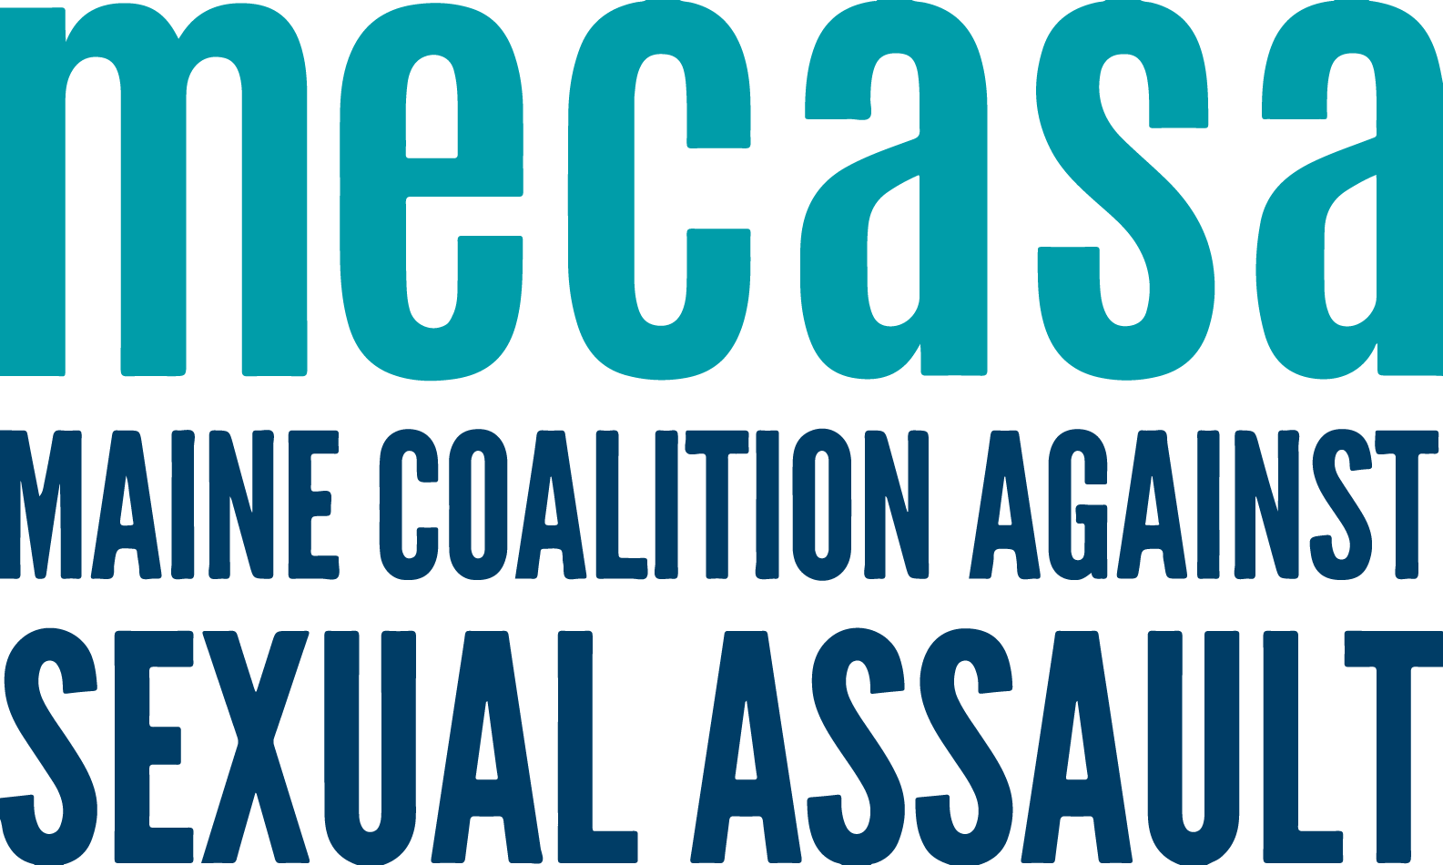
Rural Peer Support Call

Background
In 2016 Maine sexual assault support centers received two funding sources to expand services to rural survivor and rural communities - VOCA and OVW Rural. Both advocated for using funds for services, but also the necessary staff time needed to develop relationships, do outreach, and train community partners.

Part of that funding also included a commitment from MECASA to work with rural advocates to develop specialized tools and programming in support of rural communities.

Group Purpose
This group will serve as a shared space for discussion of rural programming. Members can share knowledge, best practices, and lessons learned. It will be a place to inform statewide rural related projects.

Timeframe
This call will be bimonthly for 60 minutes – opposite the Incarcerated Services calls. Calls will have topics determined in advance; calls times, topics, and zoom links will be posted on the toolkit.

Members
- Any member center staff member providing programming in rural communities
- Join only after reaching agreement with their ED or supervisor
- Share and provide feedback, seeking additional information from their center as needed.
- Communicate about meetings and activities of the group with their ED.
- Inform the work of the group with knowledge and expertise about their communities.
- Collaborate on shared projects that reflect both centers’ expertise and a statewide purpose.

Group Guidelines
The standing group guidelines for all MECASA Peer Support Calls are:
- Acknowledge and learn from different approaches to the work
- Direct and ethical communication – if you have an issue with a singular agency or person, have that conversation directly, not in the Peer Support Call
- Do not share client information, including any identifying information

