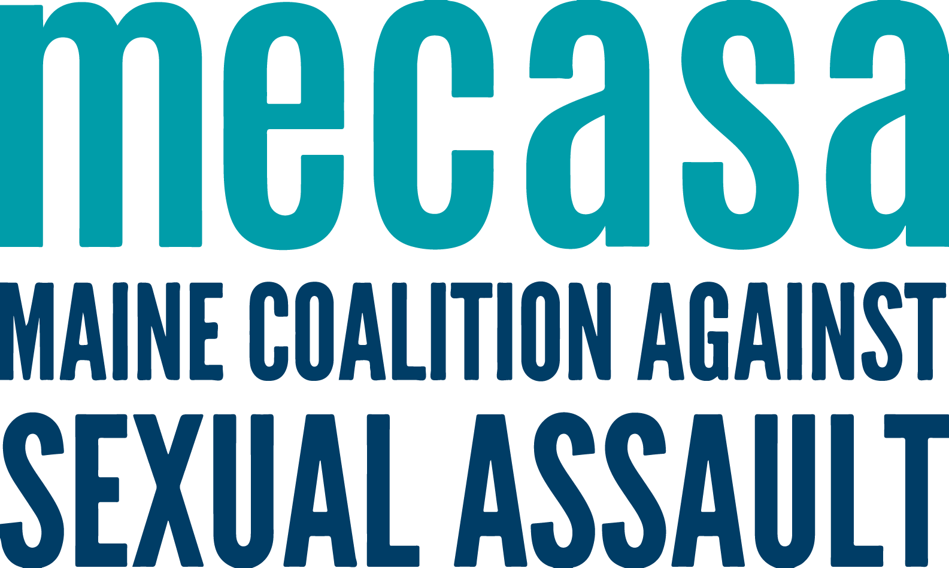
Incarcerated Services Peer Support Call
2023 Purpose & Plan

Background
In 2022, member center staff attending the quarterly Maine Sex Trafficking & Exploitation Network (STEN) identified the need for coordination of services for when working with those who are incarcerated. Advocates have observed that they are working with survivors who are incarcerated in one part of the state, but live in another, so their supports and resources are far away. It makes sense to have contact with a statewide network of advocates and support services.

At the time of this request for an Incarcerated Services Peer Support Call, MECASA staff was at facilitation capacity, so the group met on their own to get the ball rolling. But as of FY23, MECASA is coordinating the logistics, calendar, and agenda, while the group will determine the scope and discussion topics.

This Peer Call is different than others offered by MECASA because it includes advocates from domestic violence and case workers from the trafficking field. As the original request came from a MDT audience, we’re going to continue to convene DV, sexual assault, and trafficking services together, in collaboration with the Maine Coalition to End Domestic Violence and Preble Street Anti-Trafficking Services.

Group Purpose
This group will serve as a shared space for discussion of supports and services available to those incarcerated. Members can share knowledge, best practices, and lessons learned. It will be a place to inform statewide incarcerated related projects.

Timeframe
This call will be bimonthly for 60 minutes. Calls will have topics determined in advance; calls times, topics, and zoom links will be posted on the Toolkit.

Members
- Any member center staff member providing services to incarcerated survivors of sexual violence, domestic violence, and trafficking
- Join only after reaching agreement with their ED or supervisor
- Share and provide feedback, seeking additional information from their center as needed.
- Communicate about meetings and activities of the group with their ED.
- Inform the work of the group with knowledge and expertise about their communities.
- Collaborate on shared projects that reflect both centers’ expertise and a statewide purpose.

Group Guidelines
The standing group guidelines for all MECASA Peer Support Calls are:
- Acknowledge and learn from different approaches to the work
- Direct and ethical communication – if you have an issue with a singular agency or person, have that conversation directly, not in the Peer Support Call
- Do not share client information, including any identifying information

