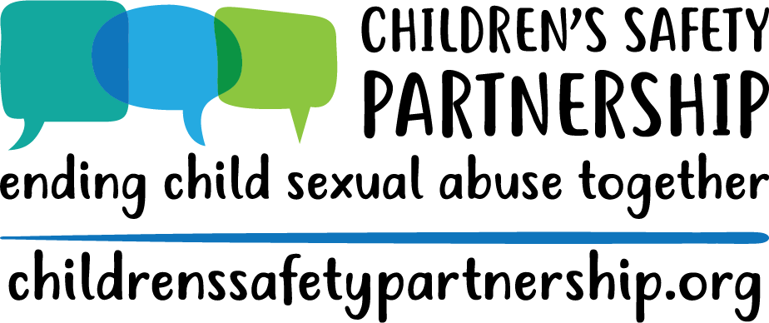

Understanding and Responding to Child Sexual Abuse
Personnel Awareness Training
1-hour training - VIRTUAL

Materials | -- | --
- One Hour Virtual Training PowerPoint
- Padlet Account
- Mentimeter Account
- “Responding to Sexual Behaviors” handout

Introductions | Slide 1 | 3 mins
- Introductions & Pronouns
  - Explain that pronouns are simple way to promote inclusivity in a space.
Using Zoom | Slide 2 | 1 mins
  - Take the time to explain how Zoom will be used.
    - Feel free to gauge the comfort level by asking them to respond in the chat on a scale of 1-5 how comfortable they are with Zoom.

Group Agreements, Who is in the Room, Outcomes | Slides 3-6 | 4 mins
- Share group agreements and explain that we establish these because CSA is a challenging topic. Encourage people to take care of themselves as they need to for the duration of and after the training.
- Who is in the Room?
  - To get a feel for who your audience is, invite participants to use the annotate feature to stamp which role they fill at their school(s).
  - Once you have an idea, acknowledge the expertise in the room and explain that you will be drawing on that throughout the training, but that we also don’t want to assume that everyone has the same working knowledge of the content.
- One word for the day:
  - If folks are reporting feeling nervous, anxious, uneasy, etc. acknowledge that. Remind them that this is a challenging topic and not one that folks particularly enjoy talking about and that is why we remind folks at the beginning to take care of themselves. Tell them that your goal is to make the information digestible and that you are happy to answer questions and engage in productive conversations with participants so they feel they have the tools they need to respond to sexual behaviors and make reports if necessary.
- Review outcomes:
  - Provide overview of the state law and policy regarding CSA prevention education and response
  - Increase understanding of child sexual abuse
  - Increase awareness of sexual development, including appropriate and inappropriate behaviors
  - Increase ability to effectively respond to student disclosures, sexual behavior, or suspicions of child sexual abuse
  - Understand school district’s response and referral system to incidences of suspected child sexual abuse
  - Increase awareness of local resources
- Emphasize to participants:
  - Ultimately, we want people to know how to appropriately respond to behaviors and how to make referrals keeping in mind, do no harm!
  - You do not have to handle this by yourself, the system is very important.
  - Some people/staff will be more comfortable responding then others and that is okay.
  - Use those who are more comfortable and trained to respond.

Overview of Law | Slides 7-10 | 5 minutes
- Slides 8: Review highlights of the law
- Slide 9: Go to the website, overview layout, highlight a few pages, and focus on the school systems section.
  - This is excellent chance to screen share but if you are running low on time, just give an overview of what the website has for resources and encourage folks to explore it after the training and bookmark it as a resource.
- Slide 10: Resources
- Thoughts on the law and/or policy? Q & A

Understanding Child Sexual Abuse | Slides 11-15 | 10 minutes
- Slide 12: Read the definition or ask for a volunteer to read it aloud. You may want to ask whether any part of this definition surprises anyone.
- Slides 13: Review stats
- Slide 14: Open “How often does CSA happen?” drop-down under “Your Questions” on website
  - Review statistics in this section
  - Talk about nuances around sexual assault statistics
    - sexual abuse it the most underreported crime, imagine then for children
    - sometimes it takes long periods of time for survivors to report
    - Is the data collected retrospectively, or based on reports made?
    - Crime data vs disclosures
    - Basically, it's complicated.
- Slide 15: Who Sexually Abuses Children?
  - Are these numbers surprising?

Understanding Sexual Development | Slides 16-23 | 10 minutes
- Slide 17: Use a Zoom Poll to determine ages groups your participants work with:
  - Preschool Age (0-5)
  - Younger School Age (5-9)
  - Older School Age (9-12)
  - Adolescence (13-16+)
  - If your group mainly reports those outside the pre-k through 5 span, explain that this training and this information is incredibly important because their students still may report and they need to know how to respond, siblings, etc.
- Slide 18: Children’s behaviors typically fit into one of two categories: developmentally expected and potentially problematic. However, just because a behavior is “typical” or “developmentally expected” does not mean it is acceptable or appropriate in every context or in every family. Families, schools, or early education programs can make decisions about what behaviors are appropriate within each of those contexts. What this discussion does is provide a child development framework for understanding children’s sexual behaviors. Sometimes developmentally expected behaviors can still feel icky, but don’t make decisions based on that feeling, instead make decisions based on knowledge.
- Slides 19-22: Signs/behaviors broken down by age group. Be sure to leave space for questions or surprising reactions. It can be helpful to remember that the motivation behind children’s sexual behaviors is different than that of adults. For example, when children touch their own genitals, or masturbate, they do so because they have learned that the touching feels good and not because they associate it with sex. Some children will masturbate as a way of calming down or relaxing, just as other children will twirl their hair or suck their thumb to accomplish the same self-soothing effect.
- Slide 23-24: While having a list can be helpful, there is often a thin line between developmentally expected behavior and potentially problematic behaviors. If you’re unsure, report behavior. Questions about the list? Anything that needs to be added?
- Questions?

Responding to Sexual Behaviors | Slides 25-34 | 15 minutes
- Slide 26: Here are some words to use when responding to a behavior or interaction that model for the child a way of communicating that is clear and helps children learn empathy and accountability for their behavior. Remember, remain calm and continue to assess the situation. Depending on the behavior, calmly redirect when you can.
  - Model communication: be clear & direct, label the behavior for the child
  - Foster empathy: respond from a personal place and label your feelings (or another’s)
  - Promote accountability: if needed, ask clarifying, open ended questions. Then, set an appropriate limit, rule or expectation to promote the child’s responsibility for the behavior.
- Slides 27-29: Introduce model
  - Give example: I see you trying to kiss your classmate on the cheek. Your classmate pulled away and was visibly uncomfortable. At school, we do not kiss each other.
- Slide 30: Tips for responding, Examples and what to do if age appropriate
  - Refer folks to “Responding to Sexual Behaviors” Handout
- Slide 31: Group Brainstorm!
  - Use padlet to have people work together and respond to behaviors
  - Use breakout rooms for this – if there is not enough time, feel free to pick one or two scenarios and have folks type into the chat box how they could respond.
- Slide 32: Things to consider when you receive a disclosure
- Slides 33-34: What if you suspect an adult of CSA? Acknowledge that this is a tricky and uncomfortable situation. Point out red flags and talk about resources – school policy, helpline, etc., CSEC

Response and Referral System | Slides 35-38 | 10 minutes
- Slide 35: This section is about reporting CSA specifically, this is not a mandated reporting training. You all should have that as well.
- Slides 36-38: Review slide content

Connections | Slide 41 | 10 minutes
- Slide 41: Talk about local resources – helpline, local centers, Title IX coordinator
- End by going back to website again
- We want feedback/thoughts/comments on the website

Questions | -- | --

Evaluations | -- | --

