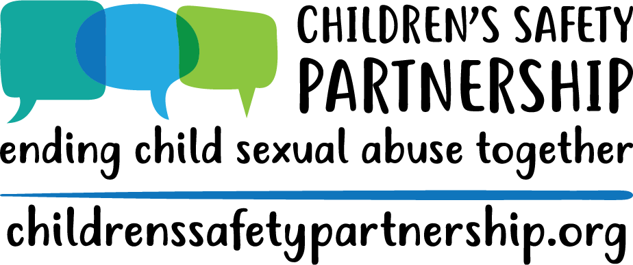

Understanding and Responding to Child Sexual Abuse
Personnel Awareness Training of Trainers
TOT Annotated Agenda - VIRTUAL

Materials | -- | --
- ToT Virtual Training PowerPoint
- Padlet Account
- Mentimeter Account
- Forced Choice activity handout
- Scenarios Handout
- “Responding to Sexual Behaviors” handout
- Components of the Law Handout
- Center Contacts List

Introductions | Slide 1 | 3 mins
- Introductions & Pronouns
  - Explain that pronouns are simple way to promote inclusivity in a space.
Using Zoom | Slide 2 | 1 mins
  - Take the time to explain how Zoom will be used.
    - Feel free to gauge the comfort level by asking them to respond in the chat on a scale of 1-5 how comfortable they are with Zoom.

Group Agreements, Who is in the Room, Outcomes | Slides 3-6 | 4 mins
- Share group agreements and explain that we establish these because CSA is a challenging topic. Encourage people to take care of themselves as they need to for the duration of and after the training.
- Who is in the Room?
  - To get a feel for who your audience is, invite participants to use the annotate feature to stamp which role they fill at their school(s).
  - Once you have an idea, acknowledge the expertise in the room and explain that you will be drawing on that throughout the training, but that we also don’t want to assume that everyone has the same working knowledge of the content.
- Hopes and Worries:
  - If folks are reporting feeling nervous, anxious, uneasy, etc. acknowledge that. Remind them that this is a challenging topic and not one that folks particularly enjoy talking about and that is why we remind folks at the beginning to take care of themselves. Tell them that your goal is to make the information digestible and that you are happy to answer questions and engage in productive conversations with participants so they feel they have the tools they need to respond to sexual behaviors and make reports if necessary.
- Review Goals for this training:
  - Learn about and understand the Child Sexual Abuse Prevention Education and Response law and what it means for your schools/districts
  - Learn the content for the one-hour personnel training and how to deliver it within your district
  - Become aware of available resources for education, referrals, and support
- Emphasize to participants:
  - Ultimately, we want people to know how to appropriately respond to behaviors and how to make referrals keeping in mind, do no harm!
  - You do not have to handle this by yourself, the system is very important.
  - Some people/staff will be more comfortable responding then others and that is okay.
  - Use those who are more comfortable and trained to respond.
  - We also want you to be able to walk away after the next two sessions and feel prepared to present the content for the one hour personnel training but we also want to acknowledge that some folks walk away and just never feel comfortable facilitating a conversation about this topic – that’s okay. There are other ways you can support the implementation of this law without being the person to present on it.

Overview of Law | Slides 7-18 | 10 mins
- Slide 8: Introduce law & how it came to be
- Slide 9: Review Components of the Law
- Slide 10: Show the model policy through the website, highlighting that all SAUs must create a policy that meets or exceeds the DOE model policy. Screen shot available on slide if there isn’t access to Internet.
  - Maine School Management Association also has a sample policy based on the DOE model policy.
- Slides 11 & 12: Show implementation guide through website. Screen shot available on slide if there isn’t internet connection
- Slide 13: Remind folks that website is and will continue to be a resource referenced throughout the training and is available for educators as well as family and community members.
- Slide 14: What the Law Says about the One-Hour Trainings
- Slide 15: Review training outcomes:
  - Provide overview of the state law and policy regarding CSA prevention education and response
  - Increase understanding of child sexual abuse
  - Increase awareness of sexual development, including appropriate and inappropriate behaviors
  - Increase ability to effectively respond to student disclosures, sexual behavior, or suspicions of child sexual abuse
  - Understand school district’s response and referral system to incidences of suspected child sexual abuse
  - Increase awareness of local resources
- Slide 16: Review what the law says about prevention education:
  - Age appropriate education regarding physical and personal boundaries, including biologically accurate body terminology;
  - Helps children identify unsafe or uncomfortable situations including a range of feelings, touches or violations of physical boundaries;
  - Helps children identify safe adults with whom they could discuss unsafe or uncomfortable situations, and;
  - Helps children identify and develop skills to support a friend who may be experiencing unsafe or uncomfortable situations.
- Slide 17: Resources – Helpline, Website
- Slide 18: Activity – Explore the CSP Website
  - Breakout rooms – Have the groups explore the website, pick 2-3 tools/pages/etc. that they can actively see themselves using. Have them discuss the following:
    - What do you think the impact of this law will be?
    - Thoughts/reactions on the policy?
    - Questions about components of the policy?
  - Make sure they have someone recording their answers so they can report back to the larger group.
- TOT Engagement:
  - Ask for questions/thoughts
  - Ask participants to assess their strengths and what areas may need developing as they go through training

Understanding Child Sexual Abuse - | Slides 19-24 | 30 min
- Slide 20: Definition of Child Sexual Abuse
- Slides 21: Review stats
- Slide 22: Open “How often does CSA happen?” drop-down under “Your Questions” on website
  - Review statistics in this section
  - Talk about nuances around sexual assault statistics
    - sexual abuse it the most underreported crime, imagine then for children
    - sometimes it takes long periods of time for survivors to report
    - Is the data collected retrospectively, or based on reports made?
      - Crime data vs disclosures
    - Basically, it's complicated.
- Slide 23: Who Sexually Abuses Children
  - Are these numbers surprising?
- Take away:
  - Sexual assault is vastly underreported
  - If a student discloses to you, they’re telling the truth

- Slide 21: Activity – Values Exercise
  - Values Exercise: Communication, response, and knowledge
    - Turn this into a Zoom Poll - Have them pick 1-5 for their response and then share the results and discuss. This keeps it anonymous. Any other ways may not allow for anonymity if that is your goal. If it is a small group with already established and good rapport, you could always annotate a likert scale slide OR have them hold up fingers/type a number into the chat box. (You can set up these questions in Zoom ahead of time)
  - Wrap up activity, transition to slides

Understanding Sexual Development - | Slides 25-34 | 30 min
- Slide 26: What ages levels do you work with?
  - Have folks use the annotate feature to indicate age groups.
  - If your group mainly reports those outside the pre-k through 5 span, explain that this training and this information is incredibly important because their students still may report and they need to know how to respond, siblings, etc.
- Slide 27: Sometimes developmentally expected behaviors can still feel icky, but don’t make decisions based on that feeling, instead make decisions based on knowledge.
  - You’ll see examples of potentially problematic behaviors on the next couple of slides. It is important to remember that factors such as frequency, interference with day to day life, and implicit harm to self and others are key indicators that a behavior has turned problematic.
- Children’s behaviors typically fit into one of two categories: developmentally expected and potentially problematic. However, just because a behavior is “typical” or “developmentally expected” does not mean it is acceptable or appropriate in every context or in every family. Families, schools, or early education programs can make decisions about what behaviors are appropriate within each of those contexts. What this discussion does is provide a child development framework for understanding children’s sexual behaviors. Sometimes developmentally expected behaviors can still feel icky, but don’t make decisions based on that feeling, instead make decisions based on knowledge.

- Slide 28-31: Developmentally expected behaviors
  - Introduce this section, share that the content may be awkward/uncomfortable to hear and to present. However, the facts are crucial. Naming stuff helps remove the stigma.
  - It can be helpful to remember that the motivation behind children’s sexual behaviors is different than that of adults.
  - Not mutually exclusive
  - While having a list can be helpful, there is often a thin line between developmentally expected behavior and potentially problematic behaviors. If you’re unsure, report behavior.
  - Questions about the list? Anything that needs to be added?

- Slide 32-33: Review content
  - While having a list can be helpful, there is often a thin line between developmentally expected behavior and potentially problematic behaviors. If you’re unsure, report behavior.
  - Questions?

This is the stopping point for session one in the virtual ToT | -- | --

Responding to Sexual Behaviors - | Slides 35-46 | 30 min
- Slide 35: Introduce the section on responding. Make it clear that we are not expecting all personnel to respond directly to students. A 1 hour workshop is not enough time to fully train staff on responding
- Slide 36-42: Outline model for responding to children’s sexual behaviors
  - People respond differently but there are protective factors helpful for interacting with survivors/victims
  - Remember, remain calm and continue to assess the situation. Depending on the behavior, calmly redirect when you can.
  - Model communication: be clear & direct, label the behavior for the child
  - Foster empathy: respond from a personal place and label your feelings (or another’s)
  - Promote accountability: if needed, ask clarifying, open ended questions. Then, set an appropriate limit, rule or expectation to promote the child’s responsibility for the behavior.
  - Introduce model
  - Give examples on slides: I see you trying to kiss your classmate on the cheek. Your classmate pulled away and was visibly uncomfortable. At school, we do not kiss each other.
  - Responding to Sexual Behaviors” Handout

- Slide 40: Review tips
- Slide 42: A Child Just Disclosed – run through list of things folks can say in direct response
- Slides 43-45: Signs and what to do if you suspect an adult of CSA, CSEC
- Slide 46: Activity – Responding to Behaviors Scenarios
  - Breakout Rooms – make sure to include link for scenarios PDF into the chat box so folks can access it. Work in your groups to go over provided scenarios – how would you respond? What about this scenario would be most challenging?
  - Scenarios – depending on group size, either split into groups OR have folks read scenarios out loud and debrief how they might respond.
  - Pause after this activity to give space for other misconceptions/addressing peer to peer situations.

Response and Referral System – | Slides 46-53 | 25 min
- Slide 47: This section is about reporting CSA specifically, this is not a mandated reporting training. You all should have that as well.
- Slide 48: Who is required to make reports? What gets reported? When? How?
- Slide 49: Considerations
- Slide 50: Things to remember AFTER a disclosure
- Slide 53: Activity – Split into District/School Groups
  - Have folks rename themselves with the number of their district (SAD 9 would just be 9) and then divide them into groups. If there are participants who are the only one from their district, either create a group that is single or two people from a district or randomly assign them to another group.
  - What are some issues or concerns you have with being able to implement this mandate in your school?

Connections – Introduce Educators/Advocates in the Room | Slides 52-54 | 10 min
- Slide 52: Talk about local resources
- Slide 53: Questions?
  - Revisit anything in the chat box that hasn’t been addressed but can be answered quickly
- We want feedback/thoughts/comments on the website

Evaluations | -- | --

